VulnTrace: Use Case and Examples
Aug 10, 2026 ·

The problem
Published fixes are hard to verify because the evidence is scattered. Three pieces rarely connect:
- The advisory says which versions are affected and which version fixed the issue. It may not name the fix commit.
- The repository has the patch, but finding the right commit can take manual searching.
- The tests may not include one that fails on the bug and passes after the fix.
Developers often upgrade because an advisory says "fixed in 2.3.1." They rarely check whether the fix is in their code or covered by a test. Security research has the same gap.

What VulnTrace does, step by step
- Reads the advisory from a JSON file, checks its fields, and records what is missing without guessing.
- Finds the fix commit only when the advisory names it explicitly, such as a tag or a SHA. It never infers a fix from words in a commit message.
- Identifies the vulnerable version as the commit before the fix. This is marked as an inference.
- Summarizes the patch: which files changed and how many lines.
- Runs the chosen test several times on the vulnerable version and the patched version.
- Gives a status and explains why, based on the outcomes.
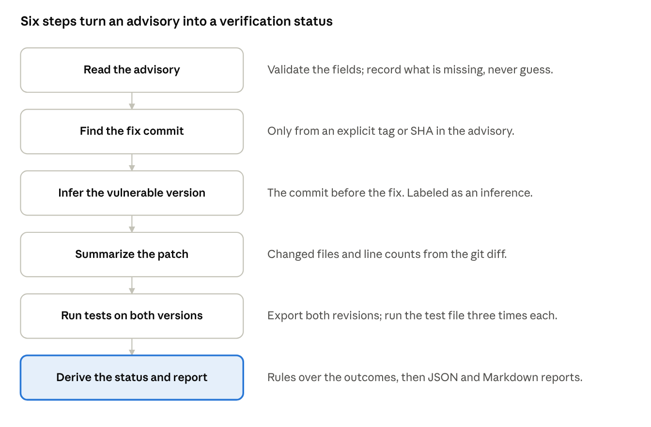
analysis pipeline · six steps from advisory to status
Steps 1 to 4 read the advisory and git history. Step 5 is the only one that runs code.

Example 1: a full verification
The advisory says "fixed in tag vt-synthetic-fixed." The test file has three tests, and two of them check path traversal.
Result: VERIFIED_FOR_TESTED_CASE. The traversal tests fail on the vulnerable version and pass on the patched version, in all three runs.
Read this carefully: the fix is confirmed for these tests only. It does not show the software is secure, and it says nothing about other attack paths.

Example 2: a passing test that proves nothing
The advisory is the same, but the test file contains only a normal-path test. That test passes on both versions.
Result: INSUFFICIENT_EVIDENCE.
A passing test can give false confidence. Here the test also passes on the vulnerable code, so it cannot show that the fix changed anything. A reviewer who only looks for a green checkmark would miss this.

Example 3: a fix with no test
The advisory references a fix commit, but no test is available.
Result: PATCH_IDENTIFIED.
The link between advisory and commit is established, but nothing has been verified. This is the honest answer when a maintainer patched a bug without adding a regression test.
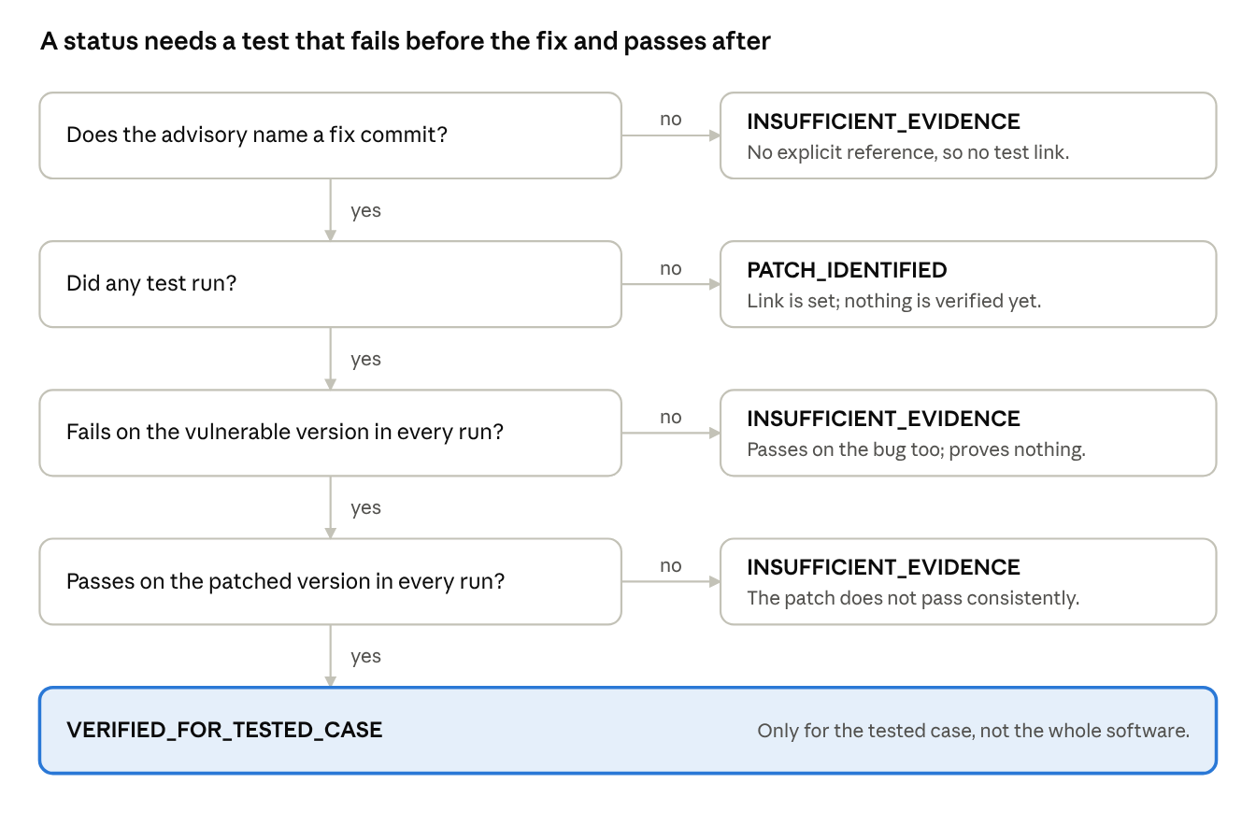
how a status is decided · four checks, simplified
This is the main path through the status rules. The tool also checks for infrastructure errors and inconsistent runs.

Who would use it and how
- Security researchers build a dataset of advisories and check, at scale, how many have a traceable fix and a test that distinguishes the versions.
- Developers upgrading dependencies can check whether the fix commit exists in the code and whether a test covers it, before trusting "upgrade to 2.3.1."
- Maintainers reviewing backports confirm that the test which fails on the old branch passes after the backport.
- Security teams writing reports get confirmed facts, observations, inferences, and unknowns listed separately.
- Students and reviewers can see what was tested, and what was not, because the method is written down before results are reported.

What it cannot do yet
- It analyzes only local repositories and the synthetic example. No real CVE has been analyzed yet.
- It cannot find the right test for you. Someone must choose the test file.
- It cannot say whether a fix is complete. Only a test shows that, and only for the cases the test covers.
- It has no web API or dashboard yet. You run it from the command line.
- It is not a security sandbox. Do not run tests from repositories you do not trust.

The research framing
The research question is whether linking these artifacts gives better verification than advisory metadata alone. Answering it needs a real dataset, a baseline, and honest reporting, including negative results. The prototype provides the pipeline for that comparison. The comparison itself has not been run yet.

